**LAB 12**

1.

package sample;  
  
  
import javafx.application.Application;  
import javafx.event.ActionEvent;  
import javafx.event.EventHandler;  
import javafx.fxml.FXMLLoader;  
import javafx.geometry.HPos;  
import javafx.geometry.Insets;  
import javafx.scene.Parent;  
import javafx.scene.Scene;  
import javafx.scene.control.Button;  
import javafx.scene.layout.GridPane;  
import javafx.scene.layout.VBox;  
  
import javafx.stage.Stage;  
  
import javafx.scene.control.TextField;  
import javafx.scene.control.Label;  
  
import java.io.PrintWriter;  
  
public class main1 extends Application {  
  
 @Override  
 public void start(Stage primaryStage) throws Exception{  
  
 //fname.setPrefSize(10,10);  
 Button btn1= new Button("Button1");  
 Button btn2= new Button("Button2");  
 Button btn3= new Button("Button3");  
 Button btn4= new Button("Button4");  
 Button btn5= new Button("Button5");  
 Button btn6= new Button("Button6");  
  
 GridPane root= new GridPane();  
 root.add(btn1, 0,1);  
 root.add(btn2, 1,1);  
 root.add(btn3, 2,1);  
 root.add(btn4, 3,1);  
 root.add(btn5, 4,1);  
 root.add(btn6, 5,1);  
 primaryStage.setTitle("Ex 12_1");  
 primaryStage.setScene(new Scene(root, 350, 30));  
 primaryStage.show();  
 }  
  
  
 public static void main(String[] args) {  
 *launch*(args);  
 }  
}

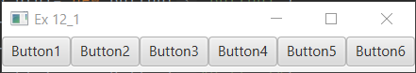

2.

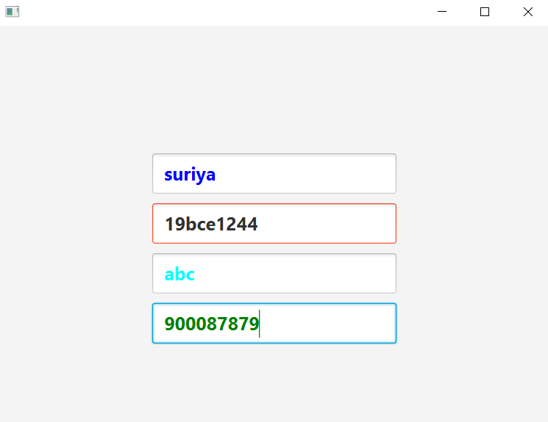

package sample;  
import javafx.application.Application;  
import javafx.event.ActionEvent;  
import javafx.event.EventHandler;  
import javafx.geometry.HPos;  
import javafx.geometry.Insets;  
import javafx.geometry.Pos;  
import javafx.scene.Scene;  
import javafx.scene.control.Button;  
import javafx.scene.layout.GridPane;  
import javafx.scene.paint.Color;  
import javafx.scene.text.Font;  
import javafx.scene.text.FontWeight;  
import javafx.stage.Stage;  
import javafx.scene.control.TextField;  
import javafx.scene.control.Label;  
import java.io.PrintWriter;  
  
public class Main extends Application {  
  
 @Override  
 public void start(Stage primaryStage) throws Exception{  
 GridPane pane = new GridPane();  
 pane.setAlignment(Pos.*CENTER*);  
 pane.setHgap(10);  
 pane.setVgap(10);  
 pane.setPadding(new Insets(25, 25, 25, 25));  
 Scene scene = new Scene(pane, 600, 475);  
 TextField name= new TextField();  
 name.setPromptText("Name");  
 name.setFont(Font.*font*("TimesRoman", FontWeight.*BOLD*,20));  
 name.setStyle("-fx-text-box-border: #FF5733;");  
 name.setStyle("-fx-text-inner-color: #000000;");  
 pane.add(name,0,1);  
  
 TextField id= new TextField();  
 id.setPromptText("ID");  
 id.setFont(Font.*font*("TimesRoman", FontWeight.*BOLD*,20));  
 id.setStyle("-fx-text-box-border: #FF5733;");  
 name.setStyle("-fx-text-inner-color: #0000FF;");  
 pane.add(id,0,2);  
  
 TextField addr= new TextField();  
 addr.setPromptText("Address");  
 addr.setFont(Font.*font*("TimesRoman", FontWeight.*BOLD*,20));  
 addr.setStyle("-fx-text-box-border: #FF5733;");  
 addr.setStyle("-fx-text-inner-color: #00FFFF;");  
 pane.add(addr,0,3);  
  
 TextField ph= new TextField();  
 ph.setPromptText("Phone");  
 ph.setFont(Font.*font*("TimesRoman", FontWeight.*BOLD*,20));  
 ph.setStyle("-fx-text-box-border: #FF5733;");  
 ph.setStyle("-fx-text-inner-color: #008000;");  
 pane.add(ph,0,4);  
  
 primaryStage.setScene(scene);  
 primaryStage.show();  
 }  
  
  
 public static void main(String[] args) {  
 *launch*(args);  
 }  
}

3.

package sample;  
import javafx.application.Application;  
import javafx.scene.Scene;  
import javafx.scene.control.Label;  
import javafx.scene.image.Image;  
import javafx.scene.image.ImageView;  
import javafx.scene.layout.GridPane;  
import javafx.stage.Stage;  
import java.io.FileInputStream;  
import java.io.FileNotFoundException;  
  
  
  
public class main1 extends Application {  
  
 @Override  
 public void start(Stage primaryStage) throws Exception{  
 try {  
 try {  
 int x,y;  
 Image image1 = new Image(new FileInputStream("C:\\Users\\DELL\\OneDrive\\Desktop\\close.png"));  
 Image image2 = new Image(new FileInputStream("C:\\Users\\DELL\\OneDrive\\Desktop\\circle-ring.png"));  
 Image image3 = new Image(new FileInputStream("C:\\Users\\DELL\\OneDrive\\Desktop\\close.png"));  
 ImageView imagev1 = new ImageView(image1);  
 ImageView imagev2 = new ImageView(image2);  
 ImageView imagev3 = new ImageView(image3);  
 GridPane root = new GridPane();  
 Label l1= new Label();  
 Label l2= new Label();  
 Label l3= new Label();  
 Label l4= new Label();  
 Label l5= new Label();  
 Label l6= new Label();  
 Label l7= new Label();  
 Label l8= new Label();  
 Label l9= new Label();  
 x = (int) (Math.*random*() * 3) + 0; //Label1  
 System.*out*.println(x);  
 if(x==0){  
 imagev1.setFitHeight(80);  
 imagev1.setPreserveRatio(true);  
 l1.setGraphic(imagev1);  
 }  
 else if(x==1){  
 imagev2.setFitHeight(80);  
 imagev2.setPreserveRatio(true);  
 l1.setGraphic(imagev2);  
 }  
 /*else if(x==2){  
 imagev3.setFitHeight(80);  
 imagev3.setPreserveRatio(true);  
 l1.setGraphic(imagev3);  
 }*/  
 x = (int) (Math.*random*() * 3) + 0; //Label2  
 if(x==0){  
 imagev1.setFitHeight(80);  
 imagev1.setPreserveRatio(true);  
 l2.setGraphic(imagev1);  
 }  
 else if(x==1){  
 imagev2.setFitHeight(80);  
 imagev2.setPreserveRatio(true);  
 l2.setGraphic(imagev2);  
 }  
 /*else if(x==2){  
 imagev3.setFitHeight(80);  
 imagev3.setPreserveRatio(true);  
 l2.setGraphic(imagev3);  
 }*/  
 x = (int) (Math.*random*() * 3) + 0; //Label3  
 if(x==0){  
 imagev1.setFitHeight(80);  
 imagev1.setPreserveRatio(true);  
 l3.setGraphic(imagev1);  
 }  
 else if(x==1){  
 imagev2.setFitHeight(80);  
 imagev2.setPreserveRatio(true);  
 l3.setGraphic(imagev2);  
 }  
 /*else if(x==2){  
 imagev3.setFitHeight(80);  
 imagev3.setPreserveRatio(true);  
 l3.setGraphic(imagev3);  
 }*/  
 x = (int) (Math.*random*() * 3) + 0; //Label4  
 if(x==0){  
 imagev1.setFitHeight(80);  
 imagev1.setPreserveRatio(true);  
 l4.setGraphic(imagev1);  
 }  
 else if(x==1){  
 imagev2.setFitHeight(80);  
 imagev2.setPreserveRatio(true);  
 l4.setGraphic(imagev2);  
 }  
 /*else if(x==2){  
 imagev3.setFitHeight(80);  
 imagev3.setPreserveRatio(true);  
 l4.setGraphic(imagev3);  
 }*/  
 x = (int) (Math.*random*() * 3) + 0; //Label5  
 if(x==0){  
 imagev1.setFitHeight(80);  
 imagev1.setPreserveRatio(true);  
 l5.setGraphic(imagev1);  
 }  
 else if(x==1){  
 imagev2.setFitHeight(80);  
 imagev2.setPreserveRatio(true);  
 l5.setGraphic(imagev2);  
 }  
 /*else if(x==2){  
 imagev3.setFitHeight(80);  
 imagev3.setPreserveRatio(true);  
 l5.setGraphic(imagev3);  
 }*/  
 x = (int) (Math.*random*() * 3) + 0; //Label6  
 if(x==0){  
 imagev1.setFitHeight(80);  
 imagev1.setPreserveRatio(true);  
 l6.setGraphic(imagev1);  
 }  
 else if(x==1){  
 imagev2.setFitHeight(80);  
 imagev2.setPreserveRatio(true);  
 l6.setGraphic(imagev2);  
 }  
 /*else if(x==2){  
 imagev3.setFitHeight(80);  
 imagev3.setPreserveRatio(true);  
 l6.setGraphic(imagev3);  
 }*/  
 x = (int) (Math.*random*() * 3) + 0; //Label7  
 if(x==0){  
 imagev1.setFitHeight(80);  
 imagev1.setPreserveRatio(true);  
 l7.setGraphic(imagev1);  
 }  
 else if(x==1){  
 imagev2.setFitHeight(80);  
 imagev2.setPreserveRatio(true);  
 l7.setGraphic(imagev2);  
 }  
 /*else if(x==2){  
 imagev3.setFitHeight(80);  
 imagev3.setPreserveRatio(true);  
 l7.setGraphic(imagev3);  
 }*/  
 x = (int) (Math.*random*() * 3) + 0; //Label8  
 if(x==0){  
 imagev1.setFitHeight(80);  
 imagev1.setPreserveRatio(true);  
 l8.setGraphic(imagev1);  
 }  
 else if(x==1){  
 imagev2.setFitHeight(80);  
 imagev2.setPreserveRatio(true);  
 l8.setGraphic(imagev2);  
 }  
 /*else if(x==2){  
 imagev3.setFitHeight(80);  
 imagev3.setPreserveRatio(true);  
 l8.setGraphic(imagev3);  
 }*/  
 x = (int) (Math.*random*() * 3) + 0; //Label9  
 if(x==0){  
 imagev1.setFitHeight(80);  
 imagev1.setPreserveRatio(true);  
 l9.setGraphic(imagev1);  
 }  
 else if(x==1){  
 imagev2.setFitHeight(80);  
 imagev2.setPreserveRatio(true);  
 l9.setGraphic(imagev2);  
 }  
 /*else if(x==2){  
 imagev3.setFitHeight(80);  
 imagev3.setPreserveRatio(true);  
 l9.setGraphic(imagev3);  
 }*/  
 root.add(l1, 1, 1);  
 root.add(l2, 2,1);  
 root.add(l3,3,1);  
 root.add(l4,1,2);  
 root.add(l5, 2, 2);  
 root.add(l6, 3,2);  
 root.add(l7, 1,3);  
 root.add(l8,2,3);  
 root.add(l9,3,3);  
 primaryStage.setTitle("Ex 12_3");  
 primaryStage.setScene(new Scene(root, 600, 600));  
 primaryStage.show();  
 } catch(IllegalArgumentException e){  
 e.getStackTrace();  
 }  
 } catch (Exception e) {  
 e.printStackTrace();  
 }  
 }  
  
  
 public static void main(String[] args) {  
 *launch*(args);  
 }  
}

